**Sales Predictions**

**Item Sales Prediction Analysis**

**Author**: George Ajayi

**Business problem:**

We need a model that can predict the Item Outlet Sales result

**Data:**

The Data source is a csv flat file Data named sales prediction which consist of 12 columns and 8524 rows. The 3 datatypes in this dataframe are object, float and an integer. Numeric and Categorical data.

**Methods**

* Import Packages
* Load Data
* Explore Data
* Perform a Validation Split
* Create for Preprocessing
* Create a Model Pipeline
* Fit the Model Pipeline on the Training Data and Make Predictions
* Evaluate the Model

**Results**

**Boxplot Visualization** [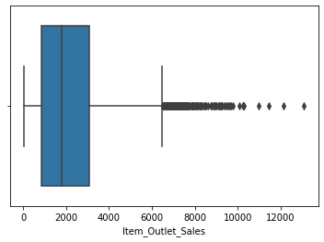](https://github.com/coding-dojo-data-science/Project-1/blob/main/project1_sample_image.png)

Above is a boxplot visualization of the (y) target which signifies some outliers.

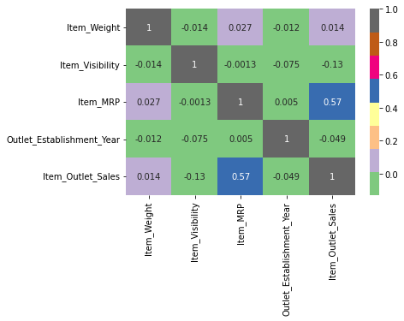**Visual 2 Title**

By my right is a heatmap

Visualization that shows a positive

Coefficient correlation between

2 columns in our data;

Item_MRP (the feature) and

Item_Outlet_Sales which is the target.